____’s Behavior Chart
A Day
Date: | Be Respectful | Complete My Work | Follow the Rules
Arrival & Morning Checklist
Math
(9 – 10)
Language Arts (10 – 11)
Recess
(11 – 11:30)
Lunch
(11:30 – 12:00)
Language Arts
(12 – 1)
Language Arts
(1 – 1:35)
Media
(1:35 – 2:20)
(2:20 – 3:00)
TOTAL
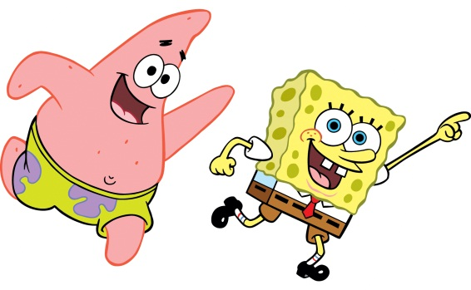
If I earn_________’s, I will earn_______________________________________ (Reward)
If I earn ________X’s, I will __________________________________________ (Consequence)

TODAY I EARNED:

